|  |
| --- |
| https://baysiderefugeesupport.files.wordpress.com/2016/04/brasa_full_size_minus_border.pngB.R.A.S.A. News |
| Bayside Refugee Advocacy & Support Assoc. 3rd January 2023 |
| Edited by Geraldine Moore |
| cid:image001.jpg@01D91F62.67A67AC0 |

W

e start 2023 on a hopeful note. Over the recent two weeks the Government has released possibly as many as 100 people from immigration detention. This follows a federal court decision that ruled that the practice of the Department of imprisoning people under the ‘character’ provisions of the Migration Act was not legal in all cases. Alison Battison, the director  principal at *Human Rights For All* comments that the Government’s action heralds : “a much, much more humane, legal and economically rational approach to immigration detention”. Let’s hope so.  We must keep working for the  continuation of the more humane approach to those in onshore detention. However, the reports of suffering of those in offshore detention show no signs of improvement. We will have to work hard in 2023 to see some softening of the approach to these individuals.

<https://www.theguardian.com/australia-news/2022/dec/29/up-to-100-people-released-from-immigration-detention-after-government-loses-federal-court-case>

1. CRAIG FOSTER NAMED AS ‘NEW SOUTH WALES AUSTRALIAN OF THE YEAR’ FOR HIS WORK FOR REFUGEES

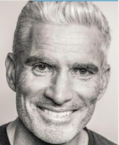

Craig Foster A.M., former Socceroo and SBS broadcaster, has been recognised for his work for asylum seekers, refugees and for his promotion of multiculturalism.

GOOD NEWS FOR CISARUA LEARNING CENTRE

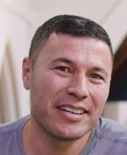

The first piece of good news is that Muzafar Ali has received the Fred Hollows ‘2022 humanitarian of the year’ award for his work for the Cisarua Learning Centre. The second piece of good news is that a campaign through Chuffed.org to raise funds for the Refugee Learning Centre’s program in Cisarua, Indonesia has exceeded its target of $30,000. This will enable it to continue its program that benefits 600 refugee students. See a 2-minute video in which the convenors: Muzafar Ali and Jolyon Hof talk about the work of the Learning Centre. (Thanks to Judy Carroll for the attached email including link to the video).

<https://chuffed.org/project/refugeelededucation>

1. MARIE HAPKE INVITES YOU TO SUBSCRIBE TO THE A.R.A.N. NEWSLETTER  
   Marie writes: in case you have not received the **ARAN Update** you can access here <https://mailchi.mp/8f6ffffe1587/december-2022-aran-update?e=8dbf31a9c2>.   Let Marie know if you do not routinely receive the ARAN Update, and she’ll make sure you do in future.     (0409252673)

We also have the recent edition of the Grandmothers For Refugees newsletter attached. Thanks to Alex Elliott for forwarding this excellent newsletter.

1. PROMISE RE TEMPORARY PROTECTION VISAS IS WELCOME, BUT DOES NOT ALLAY ALL CONCERNS: RACS DIRECTOR

Sarah Dale, Director and principal director of the Refugee Advice and Casework Service writes to us: I want to emphasise that this would only see a solution for the 19,614 people that have been granted a visa. And even though we celebrate every visa granted, especially those granted a permanent stay in Australia, it still leaves, as reported, a remaining estimated 12,000 people in limbo**.** They are all left questioning – *what about me?*  
It's critical to understand that many of these 12,000 people don't have a visa because their processing has been delayed, their case hasn't been assessed yet, or they have been impacted by bureaucratic decisions outside of their control. They could have also been refused because decision makers at the time had relied upon what is now well understood to be flawed country information, pertaining to the safety and stability of countries like Sri Lanka and Afghanistan – this has been proven simply and clearly to not be the case.   
The leaked plan for an ‘announcement’ has no details attached, no confirmation as to when and no confirmation as to how. And most concerningly, no plan for those that do not hold a visa.

See Sarah’s letter attached.

<https://www.smh.com.au/politics/federal/i-can-see-my-family-again-more-than-19-000-refugees-to-qualify-for-permanent-residency-20221216-p5c6wr.html>

<https://www.theguardian.com/australia-news/2022/dec/20/labor-to-allow-19000-refugees-to-stay-permanently-in-australia-from-early-2023>

1. NEW U.N. REPORT ON TORTURE URGES CHANGES TO AUSTRALIA’S REFUGEE POLICY

A new report of the United Nations Committee Against Torture has rebutted the claim of Australia to avoid responsibility for people in offshore detention. The Committee found that Australia maintains legal responsibility because they remain under Australia’s effective control as they were transferred by Australia “to centres run with its financial aid and with the involvement of private contractors of its choice”. It urged the Australian Government to end offshore processing and transfer all people to Australia.

<https://www.refugeecouncil.org.au/new-un-report-on-torture-urges-changes-to-australian-refugee-policy/>

1. CALL FOR EVACUATION OF REFUGEES FROM PNG AND NAURU

Many of the refugees and asylum-seekers in PNG and Nauru are in urgent need of critical health care. It is understood that their mental health is so compromised that UNHCR is unable to progress claims of refugee status. So far the Australian Government is refusing to bring these people here for the care they need. See ARAN Newsletter.

1. INDONESIA’S ACT OF HUMANITY STANDS IN CONTRAST TO AUSTRALIA’S INHUMANITY

The United Nations refugee agency has praised Indonesia for its decision to save the lives of an estimated 472 Rohingya refugees who have arrived in its waters in recent weeks. A Rohingya refugee activist has criticised the “shameful example’ that  Australia has set to the world by its treatment of refugees, and called on Australia to follow Indonesia’s example.

<https://www.smh.com.au/world/asia/indonesia-s-act-of-humanity-saved-hundreds-of-rohingya-lives-says-un-20221227-p5c916.html>

1. UNEQUAL MERCY: THE WEST’S APPROACH TO REFUGEES

Helen Benedict, a professor of journalism at Columbia University has written a thoughtful summary about the unequal treatment of refugees meted out by countries such as the U.S. and Europe. She draws particularly on her first-hand experience of the situation in Greece which was the central theme of her recently published book, *Map of Hope and Sorrow: Stories of refugees trapped in Greece.*

<https://countercurrents.org/2022/12/unequal-mercy-the-wests-approach-to-refugees/>

1. UPDATE TO LIST OF REVIEWS OF BOOKS ABOUT THE REFUGEE ISSUE

Kevin Bain has updated his list, and Robert has posted it on the BRASA website *baysiderefugeesupport.org*  It is also attached. Kevin writes: “While the personal stories get attention, most of the new books go unread beyond specialists and boffins, so I want to bring these to the attention of local supporters while these new books are in the shops or in print. It's now Version 25 because publishing the review a.s.a.p. after publication helps this goal. For that reason also, the books are in the order of newest to oldest for that to work best.”

1. Reminder:

re groceries for Friends of Refugees. These can be left on the front veranda at 62 Sims Street, Sandringham or at 16 Imperial Avenue, Caulfield South.

10 Roadside vigils during the morning peak hour will re-commence this week. Our team would love to hear from any members or friends who would care to join us. Please call me on 0408512522 or 0406694358.

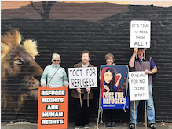

KARIMA’S CROWD-FUNDING FOR PRIVATE SPONSORSHIP TO CANADA APPROACHES HALF-WAY MARK

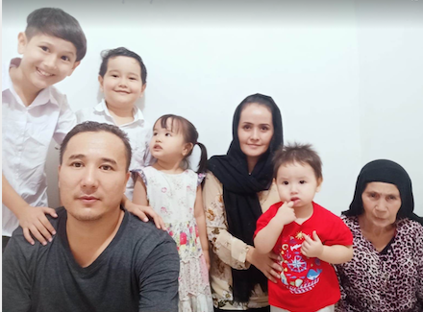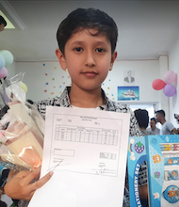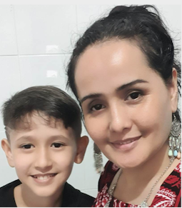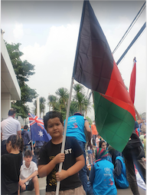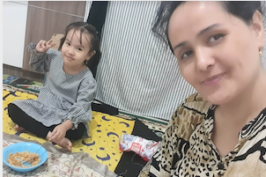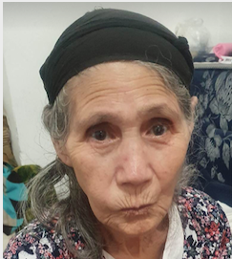

The following article was posted on Facebook by Carolyn Arthur.

**"We know where you work. We know your address. There is no place we can’t find you.”**

Those were the chilling words that spurred Afghan midwife, Karima Hakimi into action once again.

Karima has dedicated her life to the safety of women and children as a midwife, facilitator and medical officer overseeing multiple health centres. Due to her work which included educating women in rural communities, Karima was targeted by the Taliban.

She and her family fled numerous times over three years until the Taliban located her in Kabul. She then realized there was no safe place in Afghanistan.

Escaping to Indonesia, Karima and her family were bounced around until finally settling into a refugee camp in Tangerang for the past six years.

Karima is well educated and has a deep passion to continue her work by acquiring her PhD in public health. She is determined, compassionate and feels a strong responsibility to aid as many women and children as possible. Included in her family are her 75-year-old adoptive mother who could not be abandoned to the Taliban and her daughter who was born with a heart condition. She is hopeful for her children to be educated in Canada so they too, can help others.

This fundraiser needs $60,000 (Canadian) to provide Karima and her family first year living expenses. As UNHCR refugees, they are eligible for the private sponsorship program. It is the hope that with funding established, it will be easier for a group of 5 Canadian friends to sponsor them.

Born in 1987, Karima never knew her biological mother who died in childbirth. Her father, unable to care for a newborn baby, gave her to a couple without children. When Karima found out how her mother died and learned that Afghanistan had the highest rate of maternal mortality in the world, she was inspired to enter the world of health care with a focus on saving women and children.

Driven by this goal she became a home teacher at 15 years of age which earned her enough money to cover her own school fees. She also began encouraging other girls to study nursing and midwifery so they too might save lives.

Over the next nine years Karima would work towards saving women and educating girls in rural communities to perform midwifery. She worked as a midwife with the Bakhter Development Network in Daikundi, in the Istiqlal Public Hospital in Kabul and a trainer with Agha Khan Health Services in Baghlan. She was recognized and promoted to provincial mother and child health officer overseeing midwives in eleven health facilities in the province of Baghlan.

Karima also worked with the CIDA (Canadian International Development Agency) project in Afghanistan for 4 years, implementing AKHSA ( Aga Khan Health Services in Afghanistan) and AKUPA ( Aga Khan University projects in Afghanistan).

<https://chuffed.org/project/85dlx2dby47n>

FUNDRAISING RAFFLE

Please support our raffle that will be drawn this Saturday, 7th January at the conclusion of our lunch at the Brighton Beach Hotel. There are three great prizes, and all proceeds will be donated to Karima Hakimi’s fundraising campaign. You can purchase tickets in advance, of if you are coming to the lunch, you can purchase tickets on the day. See attached flyer. Please circulate the flyer to your friends and relatives.



A Happy New Year to all!

Geraldine